**Objectives:**

* Simplifying exponential expressions
* Solve geometry questions.
* Solve trigonometry questions.

**Monday, 2.24.25**

**Turn in your work/solution** for the previously assigned Maxwell’s Mowing problem.

**Class Work:** Simplifying Exponential Expressions (Handout)

|  |
| --- |
| **Class Work/Homework (released SAT questions below)**  AnglesandPolygons_SATGeometry  Polygons_SATGeometry |

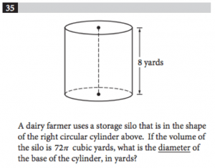

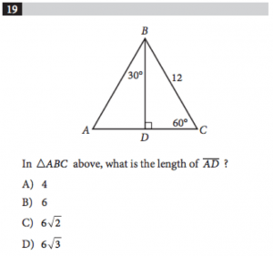

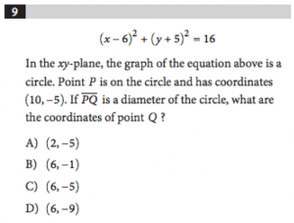

**WEDNESDAY (2.26.25**)

Discuss the previously assigned SAT questions.

Discussion of right triangle trigonometry.

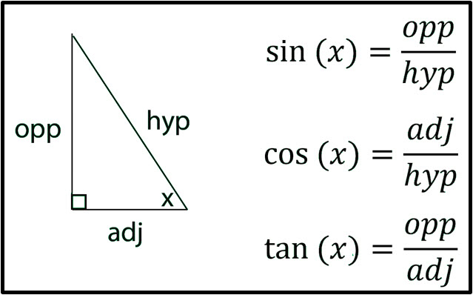

**Class Work/Homework:**

1)**Find the missing sides and angles.  
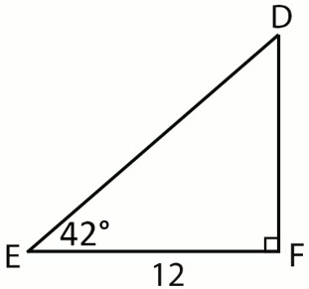**

2)**Find the missing sides and angles.  
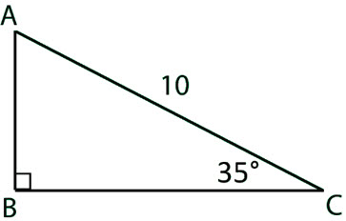**

3)**Find the missing sides and angles.  
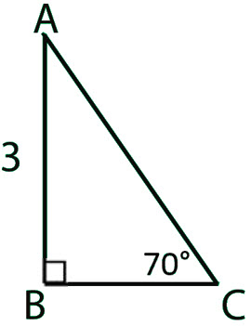**

4)**Express**cos 32∘**in terms of sine.**

5)**Express**sin 48∘**in terms of cosine.**

(6) The base of a ladder is placed 3 feet away from a 10 -foot-high wall, so that the top of the ladder meets the top of the wall. What is the measure of the angle formed by the ladder and the ground?

**Friday, 2.28.25 B-DAY, NO CLASS**